Week 1-2 Documentation
Smart-Energy-Consumption-Analysis-and-Prediction-using-Machine-Learning-with-Device-Level-Insigh
Documented by:M.Saikumar

1.Introduction:
The increasing use of electrical appliances and the lack of clear information about energy usage often lead to energy wastage, higher electricity bills, and inefficient use of devices. Traditional electricity billing systems only show total monthly consumption and do not explain which appliances consume more power or how energy is used over time.
This project proposes a Smart Energy Consumption Analysis System that monitors electricity usage for each device and analyzes energy consumption patterns over time. The system uses the SmartHome Energy Monitoring Dataset, which contains timestamp-based, device-level power data collected over six months.
Machine learning techniques such as Long Short-Term Memory (LSTM) for time-series forecasting and Linear Regression as a baseline model are used to analyze and predict future energy consumption. The system also provides interactive visualizations, energy-saving suggestions, and a web-based dashboard developed using Flask, HTML, CSS, and JavaScript.
Module-1: focuses on defining the project objectives and collecting the Smart Home Energy Monitoring Dataset. The data is checked for missing timestamps and basic inconsistencies, and organized by devices and time to understand energy usage patterns.
Module 2: prepares the data for machine learning by handling missing values and outliers. Timestamps are formatted properly, data is resampled, energy values are scaled, and the dataset is split into training and testing sets.

2.About Dataset:
This dataset provides detailed, time-based, device-level energy consumption information, which is useful for analyzing usage patterns, identifying high-energy-consuming appliances, and building machine learning models for energy prediction.The dataset contains 100,000 rows and 8 columns.
Each row represents the energy consumption of a specific appliance at a particular time in a household.
Columns:
- Home ID: Identifies each house uniquely.
- Appliance Type: Shows the type of device consuming electricity.
- Energy Consumption (kWh): Amount of energy used by the appliance in kilowatt-hours.
- Time: Time at which the energy usage was recorded.
- Date: Date of the energy consumption record.
- Outdoor Temperature (°C): Temperature outside the house at that time.
- Season: Season during which the data was recorded (e.g., Summer, Winter).
- Household Size: Number of people living in the house.

3.Loading the Dataset:
The dataset is loaded using the pandas library in Python. After loading the data into a DataFrame, the first five rows are displayed to understand the structure, column names, and sample values in the dataset. Similarly, the last five rows are printed to verify the ending records and ensure the data has been loaded correctly. This step helps in getting a quick overview of the dataset before performing further analysis and cleaning.

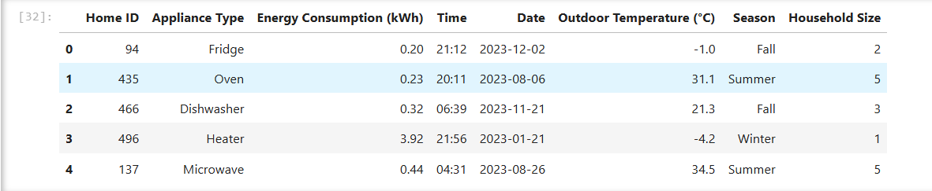
Fig.First five rows of a dataset

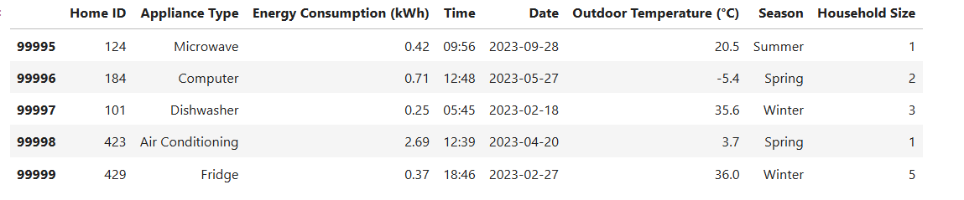
Fig.Last five rows of a dataset

4.Checking Duplicates and Null Values:
Checking for duplicate values and null (missing) values is an important step in data preprocessing because they can affect the accuracy of analysis and machine learning models. Duplicate records can cause the same data to be counted multiple times, leading to incorrect results. Null values can create errors during calculations and model training if they are not handled properly.
In this dataset, the checks show that there are no duplicate records and no null values. This means the data is clean, complete, and reliable, and it can be safely used for further analysis and model development without additional correction.

5. Visualization – Total Energy Consumption by Appliance:
This bar chart is drawn between two columns:
- X-axis: Appliance Type
- Y-axis: Energy Consumption (kWh) (total energy used)
The visualization shows the total energy consumption of each appliance by summing energy usage values for every appliance type.
Observations
- Air Conditioning and Heater consume the highest amount of energy, making them the most power-intensive appliances.
- Appliances like Dishwasher, Lights, Oven, Washing Machine, Microwave, Computer, and TV show moderate energy consumption.
- The Fridge consumes the least total energy compared to other appliances.
- This visualization clearly helps identify high energy-consuming appliances, which can be targeted for energy-saving measures.
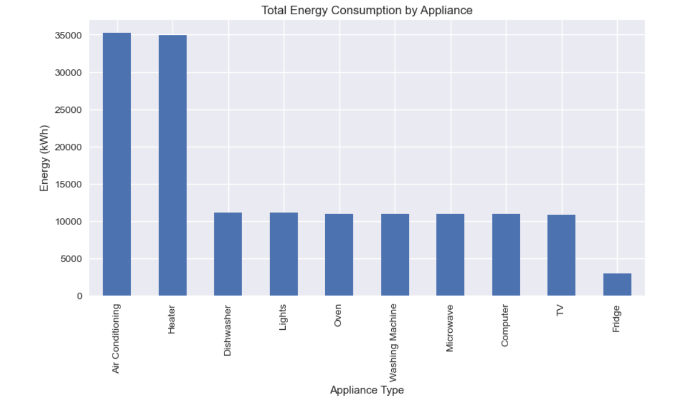

6.Energy Consumption Distribution:
This histogram shows the distribution of energy consumption values in the dataset.
- The X-axis represents Energy Consumption (kWh).
- The Y-axis shows the count, meaning how many times each energy value occurs.
Observations
- Most of the energy consumption values are low, mainly between 0 and 2 kWh.
- This indicates that most appliances consume a small amount of energy most of the time.
- Fewer readings are seen at higher energy values (above 2 kWh), which means high energy usage occurs less frequently.
- The distribution is right-skewed, showing occasional high energy consumption events.

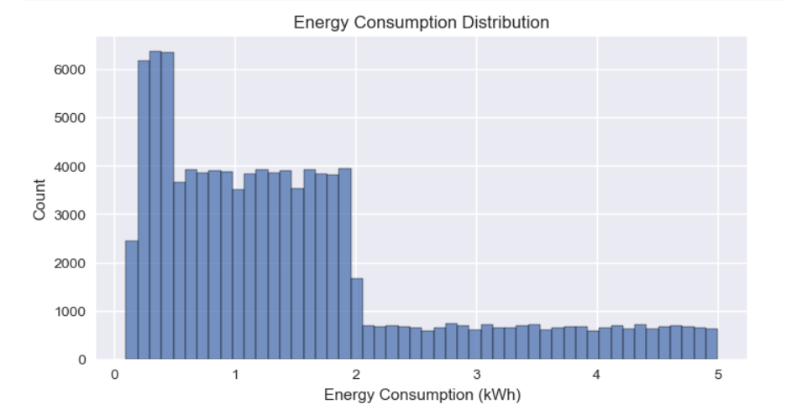

7.Timestamp:
A timestamp was created by combining the Date and Time columns into a single datetime column. This helps represent the exact moment when energy consumption was recorded. Creating a timestamp makes the data easier to analyze over time and is especially useful for time-series analysis, visualizations, and building prediction models.

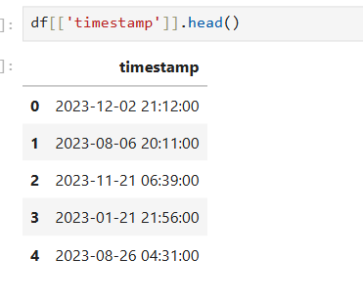
Fig:First five timestamps

